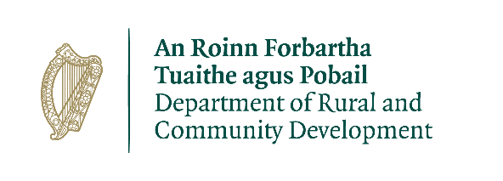

STREETSCAPE ENHANCEMENT SCHEME 2021

**DONEGAL COUNTY COUNCIL**

**Terms and Conditions**

1. This programme will be funded by the Department of Rural & Community Development and administered by Donegal County Council.
2. The scheme will offer a grant of up to a maximum cost of €8000, per property of the cost of the enhancement work - to each applicant who is successful in the application process.
3. Applications are invited from owners and/or occupiers of commercial residential and/or unoccupied buildings in the town/village centre (or any person who with the written consent of the owner/s).
4. It is a condition of eligibility the painting works proposed are required to the street facing facades only of building premises and this requirement will be determined by Donegal County Council.
5. The closing date for receipt of completed applications including two quotations is **2pm on Tuesday 7th September 2021.**
6. If the scheme is oversubscribed, applications will be prioritized on the basis of need as determined by Donegal County Council having regard to town/village renewal considerations.
7. Proposed Colour Schemes must be submitted with the quotation and are to be agreed in consultation with Donegal County Council.
8. The colour of timber elements including shopfronts will be agreed in consultation with Donegal County Council. Proposed Colour Schemes must be submitted with the quotation.
9. Grant Approval will be issued in writing to successful applicants**.**
10. Successful applicants will be required to comply with legislation and codes of practice which apply to such work. All contractors carrying out works must be tax compliant.
11. The successful applicants will be required to complete the approved works, to a high standard and within a specified time frame**.**
12. The successful applicants must **apply for payment** of the approved grant (**by submitting receipt**) when work has been completed and in any event before 1st November 2021.
13. Grant funding will be provided at the following rates:

* 70% for Individual premises – matched funding 30%
* 80% for Joint applications (groups of 3 or more adjacent premise)s – matched funding 20%
* 100% - Where painting is undertaken by direct labour by applicant

1. Payment of the grant will be subject to completion of the approved work in accordance with the conditions outlined above. Payment will generally be made by Electronic Funds Transfer to your nominated bank account.

Completed application should be emailed to

[townandvillage@donegalcoco.ie](mailto:townandvillage@donegalcoco.ie)